PBL PROBLEM RESOURCES

Title of Problem: | EC10 - Are we all the same? |  | Module: | G107 – Effective Communication
- Read the following resource: What is culture and intercultural Communication?
(Compiled by crafter):

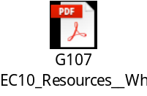

HOFSTEDE’S CULTURAL DIMENSIONS

- Read the following key resource on Hofstede’s Cultural Dimensions (Compiled by crafter):

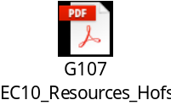

- Watch the following video for further explanation on Hofstede’s Cultural Dimensions:

Walters, M. (2013, October 18). Hofstede’s Model on Cultural Dimensions. [Video file]. Retrieved May 8, 2017, from http://www.youtube.com/watch?v=lTY6LH9WdZ4&list=PL_SGL__JLIsTorahv8G6NDTrtCu9Ko93h

THOMAS-KILMANN CONFLICT MANAGEMENT STYLE

- Read the following key resource on the Thomas-Kilmann Conflict Management Strategy (Compiled by crafter):

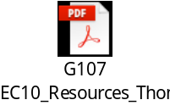

- Watch the following video for further explanation on the Thomas-Kilmann Conflict Management Strategy:

Hung, S. (2010, April 9). Conflict Styles. Retrieved May 8, 2017, from https://www.youtube.com/watch?v=hv9FEuk4Mhk

-- End of document --

